****

5.11: Worksheet 5

For each of these questions, make sure that you write a separate function, which is then run by the main(). It will be a good idea if you were to put a comment above stating which question you are answering.

For each of these questions, make sure that (where appropriate), you are validating the entry made by the user. You might want to consider writing functions to get the appropriate inputs which can be used throughout these questions.

1. Complete the questions in the in-class worksheet if they are not complete.
2. Write a function which gets the user to enter their name, and then prints hello and their name 10 times.
3. Write a program that flips a coin 100 times and then tells you the number of heads and tails. It should also calculate the percentage of times a head was “thrown”.
4. Write a function which asks the user to enter a number, and then prints out the first 20 numbers in the times table for that number.
5. Write a function which generates a random number for user to guess. The random number should be between 1 and 9 (inclusive). Ask the user to guess the number, then tell them whether they guessed too low, too high, or exactly right. The function should keep going until:
   * The user guesses the right answer (at which point the user should be congratulated, and the number of guesses printed)
   * The user reaches 10 guesses without getting the right answer (at which point the user should be told the correct answer)

*Hint: You will need to research the* random *module*

1. Adapt your answer in question 8 to allow the user to choose the difficulty of the guessing game:
   * Easy: random number between 1 and 9 (inclusive)
   * Medium: random number between 1 and 49 (inclusive)
   * Hard: random number between 1 and 99 (inclusive)
2. Write a function which outputs a “tune” based on a single word. The user should be asked a word, the number of times the word is repeated on a single line, and how many lines long the song is. An example output is:

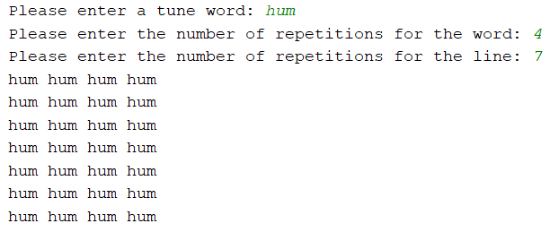

1. Write a function which requires a user to enter a number, and then output a triangle of numbers. An example output is:

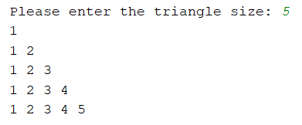

1. In the exercises completed within the timetabled sessions, we wrote a function called which printed a square of numbers. You need to adapt this function so that:
   * The user defines the height of the rectangle
   * The user defines the width of the rectangle
   * Only odd numbers are printed. The function should print a space where the even number would normally be.

For example:

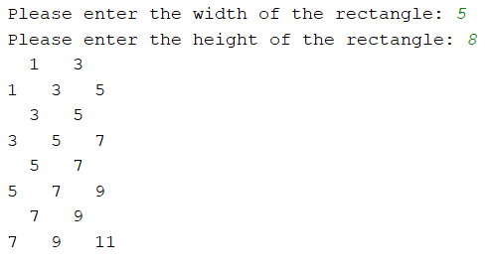

1. This question is designed to challenge you. In questions 5 and 6, you developed a function where the computer “chooses” a random number, and the user must guess what the number is. In this question, you will be developing a function which does the reverse – you as the user will choose a number, then the computer will need to “guess” what number you have chosen. It will be required that the user enters whether the computer has guessed correctly as well as whether the guess was too high or too low.